Jubilee Marie Tantoy

2 ECE D

Experiment No.8

**PANDAS**

**Problem #1**

1. Load the corresponding .csv file into a data frame named cars using pandas

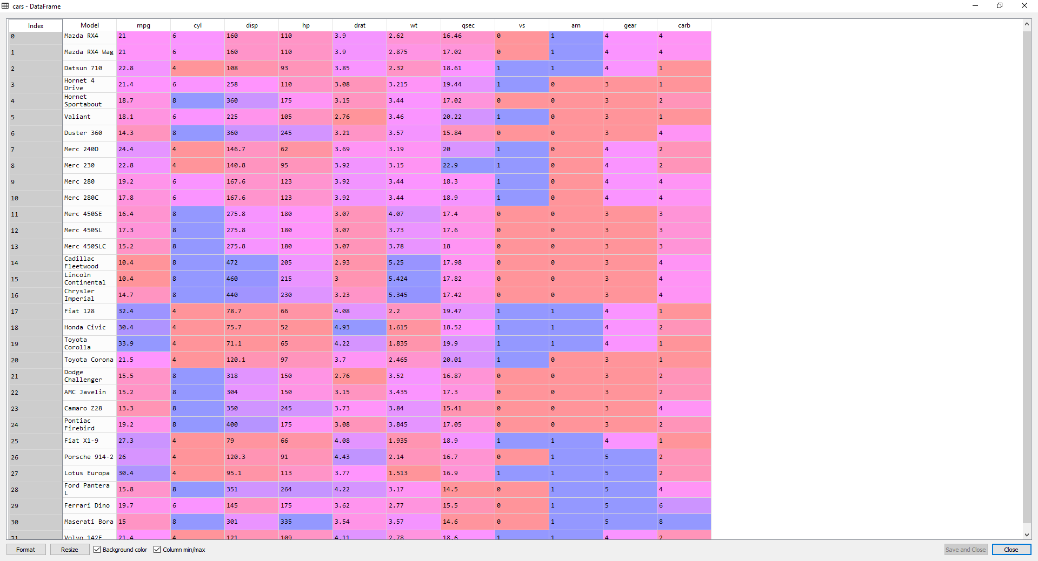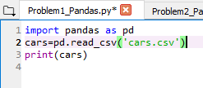

Answer:

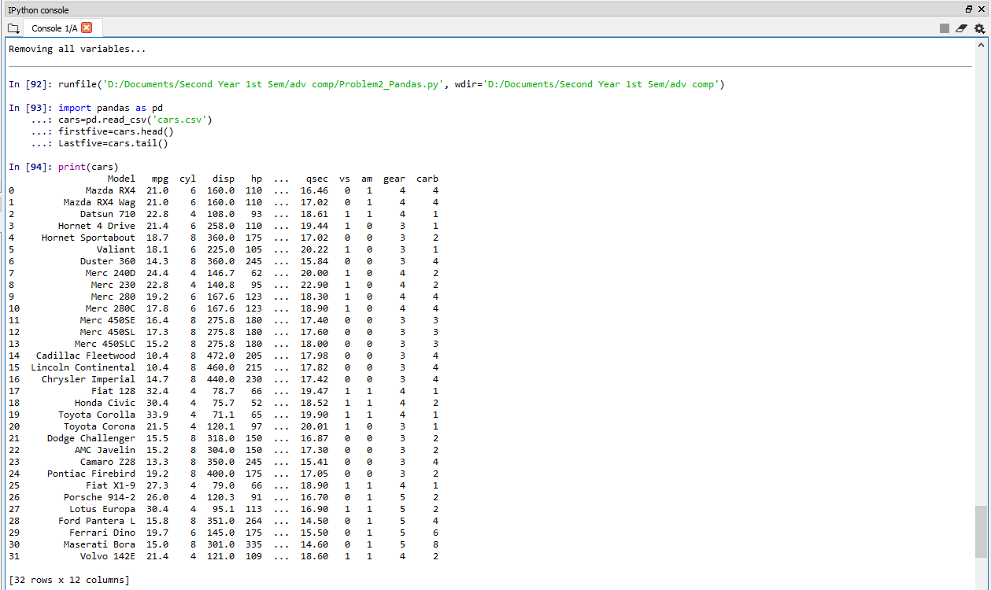

1. Display the first five and last five rows of the resulting cars

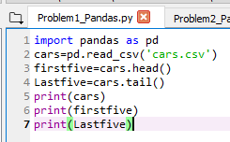

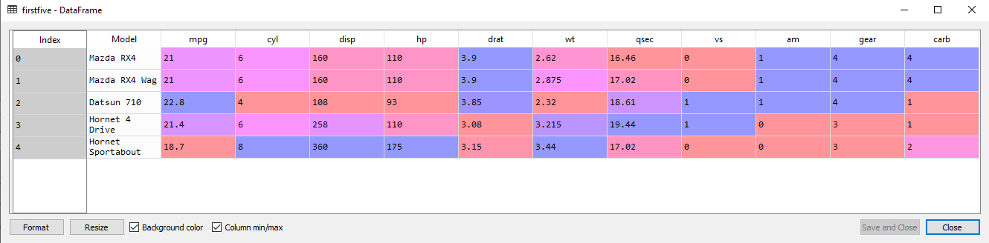

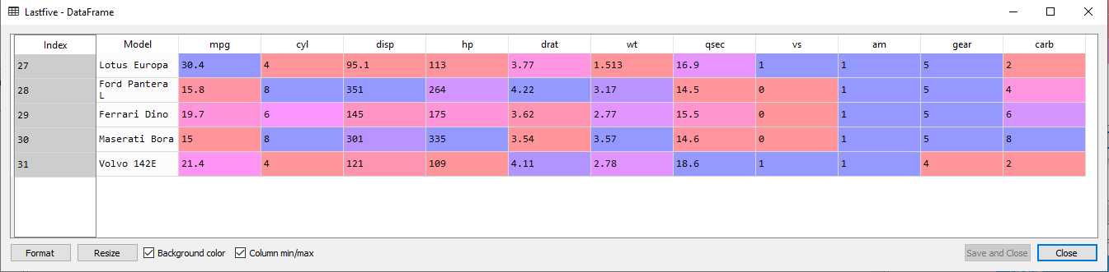

Answer:

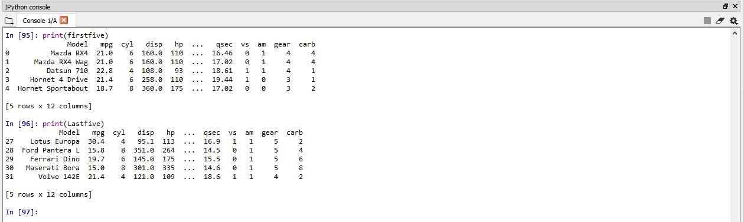

**Problem #2**

Using the dataframe cars in the previous problem, extract the following information using subsetting, slicing and indexing operations.

1. Display the first five rows with odd-numbered columns(columns 1,3,5,7…) of cars.

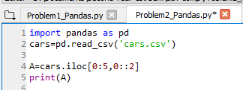

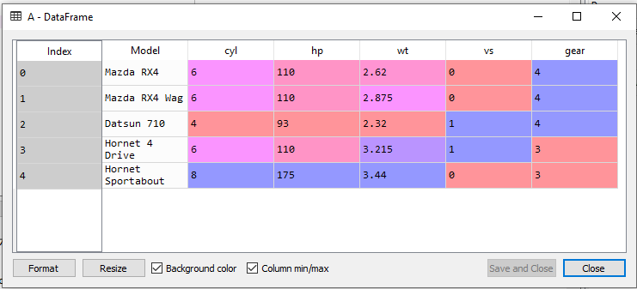

Answer: 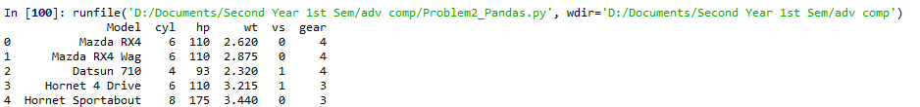

1. Display the row that contains the ‘Model’ of ‘Mazda RX4’.

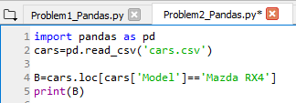

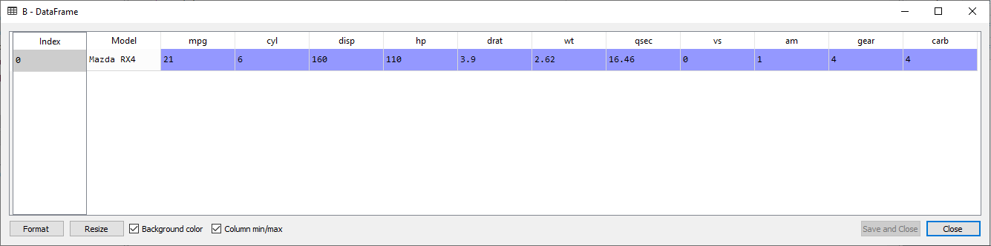

Answer:



1. How many cylinders(“cyl’) does the car model ‘Camaro Z28’ have?

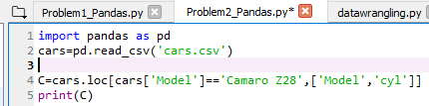

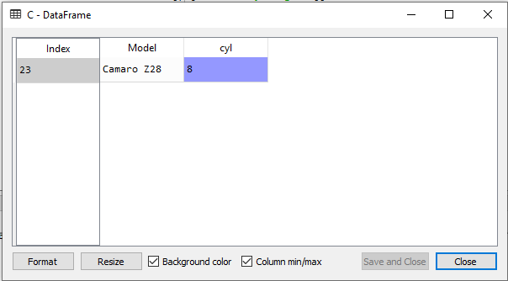

Answer: 8



1. Determine how many cyclinders (‘cyl’) and what gear type(‘gear’) do the car models ‘Mazda RX4 Wag’, ’Ford Pantera L’ and ‘Honda Civic’ have.

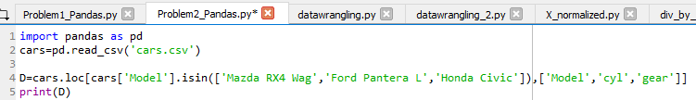

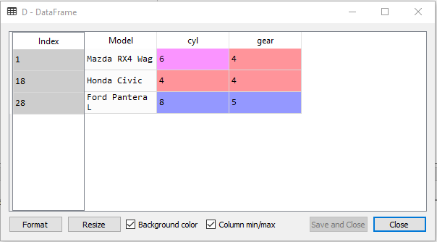

Answer:

